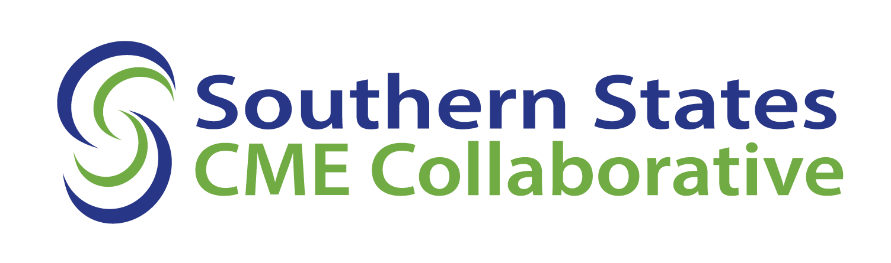
GUIDE TO YOUR SSCC ACCREDITATION DECISION
For Providers in the 2024 Cohorts
Table of Contents

Introduction 2
Your Decision 2
Accessing Your Decision 2
Accreditation Status 3
Provisional Accreditation 3
Accreditation Statement 3
Activity Review 3
Reporting CME Activity Data 4
Annual Accreditation Fee 4
Accreditation with Commendation 4
Accreditation 4
Probation 5
Non-accreditation 5
Progress Report Required 5
Your Accreditation Responsibilities 6
SSCC Accreditation Requirements 7
Accredited Provider Mark 7

Introduction
Your Decision
Upon completing the initial accreditation, reaccreditation, progress report, or reconsideration review process, your organization will receive an individualized decision from the SSCC. The decision is the SSCC’s formal notification of your organization’s accreditation status and accreditation term, as entered into the ACCME’s PARS system. The decision summarizes the SSCC’s findings related to your compliance with the Accreditation Requirements. The decision will indicate if other actions are required, such as a progress report for providers receiving reaccreditation or progress report decisions, or an activity review for providers receiving initial accreditation decisions. The decision might also contain specific language that explains the SSCC’s findings for some requirements.
Accessing Your Decision in PARS
You will access your organization’s decision report from your PARS dashboard on the ACCME website (https://pars.accme.org). The screenshots below will guide you to the information you need to review the decision. First, click on the “Back to Accreditation Management” link. Then click on the “HISTORY” tab, where you will see the most recent decision at the top, including your new term’s expiration date. Next, click on “View Decision Report” to see your decision, including compliance findings and, as applicable, descriptions of performance for the ACCME Criteria, Standards, and Policies reviewed.
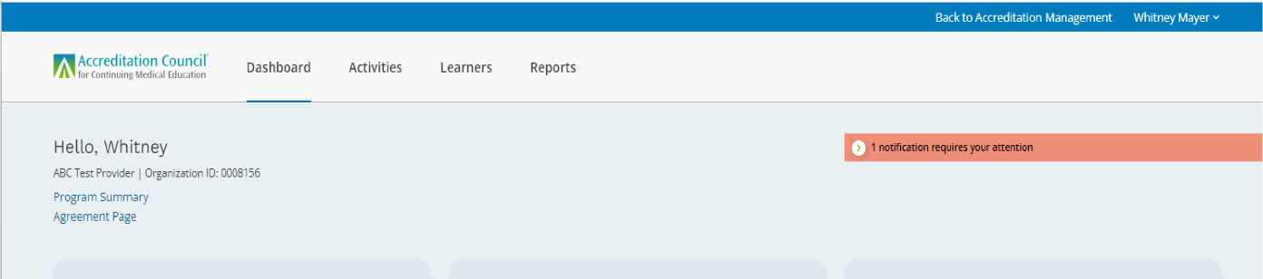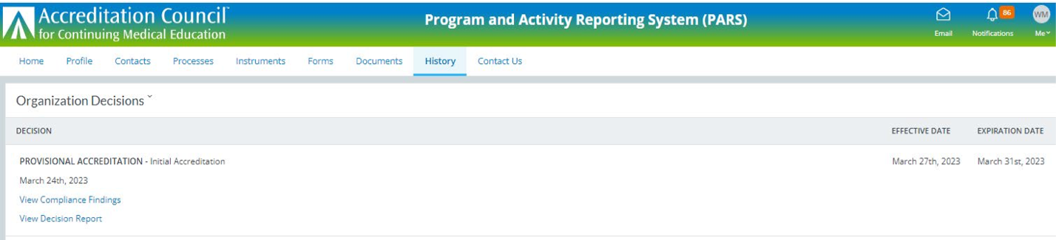
Decision Report Findings
In your decision report, there will be findings in the following categories for each Criterion, Standard, and Policy:
- Compliance (C): The provider fulfilled the ACCME’s requirements for the specific Criterion, Standard, or Policy.
Noncompliance (NC): The provider did not fulfill the ACCME’s requirements for the specific Criterion, Standard or Policy.
Accreditation Status
The accreditation decision-making process assesses a CME provider’s compliance with the Accreditation Requirements. Based on these compliance findings, the SSCC decides on the provider’s accreditation status.
Provisional Accreditation
Initial applicants seeking to achieve Provisional Accreditation, a two-year term, must demonstrate compliance with the Core Accreditation Criteria and with applicable Standards for Integrity and Independence in Accredited Continuing Education.
Accreditation Statement
With Provisional Accreditation, your organization is an SSCC-accredited provider. As an SSCC- accredited provider, your organization is responsible for using the SSCC accreditation statement to identify your organization as the entity responsible for demonstrating compliance with all SSCC accreditation requirements. The SSCC accreditation statement must appear on CME activity materials and brochures distributed by accredited organizations — with the exception, for example, of save-the-date activity announcements that contain only general, preliminary information about the activity, such as the date, location, and title. If more specific information is included, such as faculty and objectives, you must include the accreditation statement.
Activity Review
Your organization, as a newly accredited provider, is required to have an Activity Review to be eligible to advance from Provisional Accreditation to Accreditation. The Activity Review is in addition to the SSCC’s standard performance-in-practice review and entails:
- the observation of a CME activity of any type, as presented to learners, by an SSCC surveyor or staff member; and,
- the observer’s completion of the ACCME Activity Review Form.
Typically, the SSCC will use one of the activities selected for performance-in-practice review, usually an enduring material or an enduring or live internet activity. The SSCC will confirm the arrangements to fulfill this requirement in coordination with your organization’s November 2025 reaccreditation review.
Reporting CME Activity Data
Your organization must enter information for all accredited activities, directly or jointly provided, and fulfill year-end reporting requirements in the ACCME’s Program and Activity Reporting System (PARS).
Provider Contact Information
Your organization must maintain current, accurate contact information with the SSCC and in PARS to ensure that you receive important policy updates, as well as information specific to your organization. To protect the best interest of all parties, the SSCC and the ACCME generally limit communications to persons identified as authorized contacts by the provider in PARS.
Annual Accreditation Fee
Your organization is responsible for the timely submission of the fees that are required either to attain or maintain accreditation, including the Annual Accreditation Fee payable by January 31 of each year. Failure to meet ACCME deadlines could result in an immediate change of status to Probation and subsequent consideration by the Board of Directors for a change of status to Non-accreditation.
Accreditation with Commendation
Accreditation with Commendation is a six-year term of accreditation awarded to accredited providers that demonstrate compliance in the Core Accreditation Criteria, applicable Standards for Integrity and Independence in Accredited Continuing Education, and in 8 criteria from the Menu of Commendation Criteria, including at least one criterion from the “Achieves Outcomes” category. The SSCC encourages providers that achieve Accreditation with Commendation to publicize this accomplishment. It is important to the SSCC that the healthcare community is aware of your achievement, the work you do, and of the high standards you have met. The Accreditation with Commendation mark is available to support your communications. Please see the policies on ACCME Logo Usage and Publicizing ACCME Accreditation.
Accreditation
Accreditation is the standard four-year term awarded to providers for demonstrating compliance in the Core Accreditation Criteria and with applicable Standards for Integrity and Independence in Accredited Continuing Education. Providers that receive one or more noncompliance findings in these requirements, and potentially in applicable Accreditation Policies, receive Accreditation with the standard four-year term and are required to submit a progress report.

Probation
Probation status is assigned to providers that have serious problems meeting the Accreditation Requirements. A provider that receives Probation is required to submit a progress report. Most providers on Probation implement improvements quickly, return to a status of Accreditation, and sustain compliance. Providers cannot remain on Probation for longer than two years. Providers with Accreditation may have their status changed to Probation if their progress reports do not demonstrate correction of noncompliance issues. While on Probation, a provider may not act as a joint provider of CME activities with non-accredited entities, except for those activities that were contracted prior to the decision of Probation. If a provider receives a decision of Probation in two consecutive terms, it will be prohibited from acting as a joint provider, in any instance, until the provider regains a status of Accreditation.
Non-accreditation
Non-accreditation decisions occur when:
- An initial applicant is in noncompliance with any one of Core Accreditation Criteria and/or applicable Standards for Integrity and Independence in Accredited Continuing Education.
- A Provisionally Accredited provider has serious noncompliance issues.
- A provider on Probation fails to bring all areas of noncompliance into compliance in one or more progress reports within two years.
- A provider demonstrates recurrent noncompliance in the Standards for Integrity and Independence in Accredited Continuing Education, receives multiple decisions of Probation, and/or engages in joint providership while on Probation in violation of the joint providership policy.
Progress Report Required
The SSCC expects providers found to be in noncompliance with Core Accreditation Criteria and/or applicable Standards for Integrity and Independence in Accredited Continuing Education, and potentially with applicable Accreditation Policies, to demonstrate compliance through the progress report process.
A standard progress report review fee will be required. Please see the SSCC-accredited provider fee schedule. The fee is due upon receipt of the invoice that will be transmitted separately from the decision notification.
A progress report serves as an important opportunity for a provider to demonstrate that it has mechanisms in place to make improvements to its CME program. The requirement to improve is an integral part of the SSCC’s and ACCME’s accreditation systems. If all Core Accreditation Criteria and/or applicable Standards for Integrity and Independence in Accredited Continuing Education, and potentially Accreditation Policies, found to be in noncompliance are not corrected, the SSCC may require another progress report, a focused interview, and/or a change of status may result.
Determining in PARS if a Progress Report is Required as a result of Your Decision
From the “History” tab, click on “View Decision Report” located under the most current accreditation decision. Your decision report will open in a separate browser window. At the top of the compliance grid, you will find additional information related to your decision, including whether your organization is required to submit a progress report and the cohort the progress report will be reviewed.
If, as a result of the SSCC’s decision, your organization is required to submit a progress report, you will receive the SSCC’s Guide to the Progress Report Process: For Progress Reports to be Reviewed in the 2024 Cohorts and the SSCC Progress Report Milestones for Decisions Requiring a Progress Report document for information about the timeline and requirements of the ACCME’s progress report process.
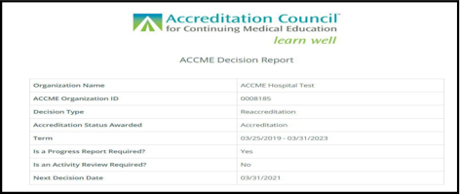

Your Accreditation Responsibilities
The SSCC expects all accredited providers to take an active, ongoing role in maintaining compliance with accreditation requirements, fulfilling their responsibilities, and improving their CME programs during their accreditation terms.
- Maintain compliance with Accreditation Requirements.
- Fulfill year-end reporting requirements in the Program and Activity Reporting System (PARS).
- Pay all accreditation fees in a timely manner, according to SSCC policy.
- Inform the SSCC of organizational changes.
- If requested, provide evidence of your continuous compliance with the accreditation requirements.
SSCC Accreditation Requirements
Your organization’s next reaccreditation will be based on demonstration of compliance with the Core Accreditation Criteria, applicable Standards for Integrity and Independence in Accredited Continuing Education, and applicable Accreditation Policies. The Menu of Commendation Criteria is an option for providers in reaccreditation review seeking Accreditation with Commendation. Compliance will be determined based on three sources of data: the self-study report that includes narrative descriptions and required document uploads to demonstrate your organization’s structure, policies, and processes; evidence of performance-in-practice from a sample of your organization’s CME activities; and the accreditation interview that clarifies the submitted materials and/or identify missing or other materials essential to the review.
The SSCC and the ACCME offer a variety of educational tools and resources to support your organization’s successful implementation of the Accreditation Requirements.
Accredited Provider Mark
Providers accredited within the ACCME System (providers directly accredited by the ACCME and those accredited by ACCME Recognized Accreditors) are welcome to use the ACCME Accredited mark for educational and identification purposes, and in announcements related to their attainment of ACCME accreditation. While the mark may be resized, the original aspect ratio should be maintained (it should not be stretched or condensed in a way that causes it to become distorted). Except for resizing, no other changes can be made. Please refer to the ACCME's policy on logo usage before downloading or using these images.

